
Tribhuvan University
Faculty of Humanities and Social Sciences

A Lab Report On
Advance Operating System (MCA502)

Submitted to
Department of Humanities and Social Science
Patan Multiple Campus

In partial fulfillment of the requirements for the Master in Computer Application
Submitted by
Bishal Rijal
MCA 1st Semester
Tu Register no:

Submitted to
Asst. Prof. Bhupendra Ram Luhar

Table of Contents
Lab-1: Installation of Linux in Virtual machine and using some Linux command 1
a. Basic command (pwd, Is, cd, cd.., mkdir, rmdir, rm – r, cp, mv, locate etc.) 1
b. Intermediate command (echo, cat, sudo, sudo password, su, sudo bash, exit etc.) 3
c. Process creation in Linux using fork() System call. 4
Lab-2: Write a program to simulate producer – consumer problem using semaphore. 5
Lab-3: write a program to simulate following CPU scheduling algorithms to find average turnaround time and waiting time. 7
Lab-4: Write program to simulate the following contiguous memory allocation algorithm 10
Lab-5: Write a program to simulate following page replacement algorithm and find the page fault 13
Lab-6: Write a Program to simulate following disk scheduling algorithms 15

Lab-1: Installation of Linux in Virtual machine and using some Linux command
Theory:
A Virtual Machine (VM) is a software-based emulation of a physical computer that runs an operating system (the "guest") on top of another operating system (the "host"), sharing the host's hardware resources like CPU, memory, and storage. Software called a hypervisor (e.g., VirtualBox, VMware) creates and manages these VMs, allowing multiple isolated operating systems to run on a single physical machine.
Here I have downloaded the kali linux Operating system and installed it on virtual machine.

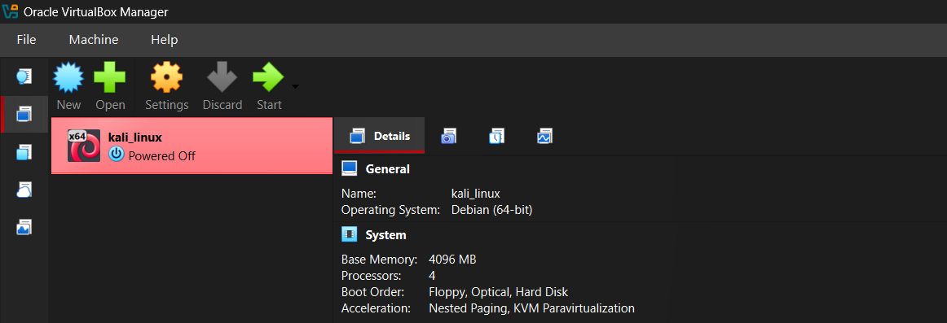

Basic command (pwd, Is, cd, cd.., mkdir, rmdir, rm – r, cp, mv, locate etc.)
Pwd: Print the absolute path of the current working directory.
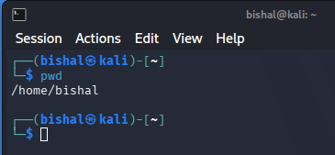

Ls: Lists the files and sub – directories present in a directory.
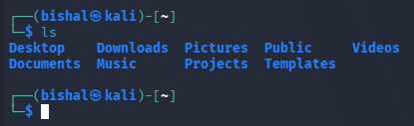

Cd: Change the currect working directory to the specified path.
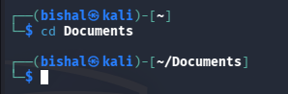

Mkdir: Creates a new directory.
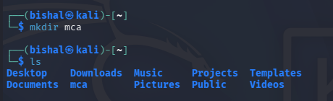

Rmdir: Removes an empty directory.
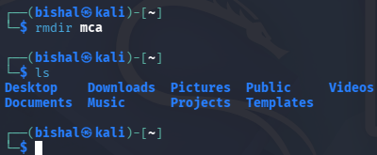

Cp: Copies of files or directories from a source to a destination.
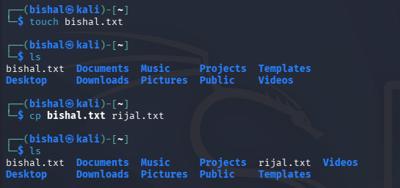

Mv: Moves or renames files and directories.
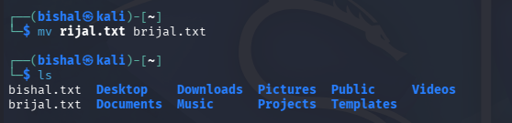

Locate: Searches for files and directories by name using a pre-built file-name database.
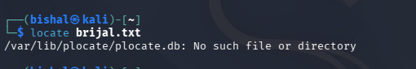

Intermediate command (echo, cat, sudo, sudo password, su, sudo bash, exit etc.)
Echo: Prints text to the terminal.
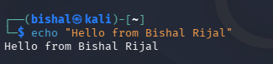

Cat: Displays the contents of a file.
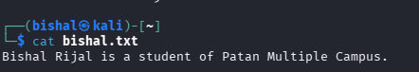

Sudo: Executes a single command with superuser (administrator / root) privileges.
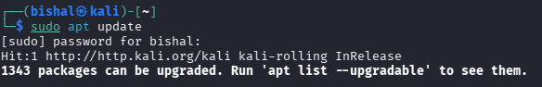

sudo passwd: Sets or changes the password of the root user account.
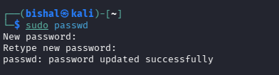

Su: Switches the current session to another user account, commonly the root user.
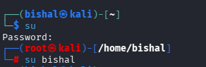

Sudo bash: Opens a new Bash shell that runs with root privileges.
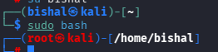

Exit: Terminates (exits) the current shell session, returning to the previous shell or user.
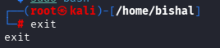

Process creation in Linux using fork() System call.
Theory:
fork() is a system call in Linux/Unix used to create a new process by duplicating the calling process. The original process is called the parent, and the newly created copy is called the child. After the call, both processes run independently from the same point in the code, each with its own memory and PID.

Source Code:
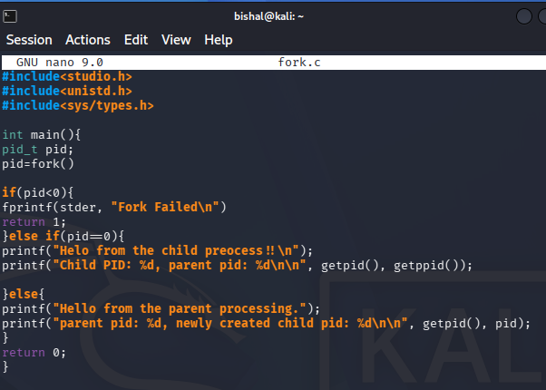

Output:
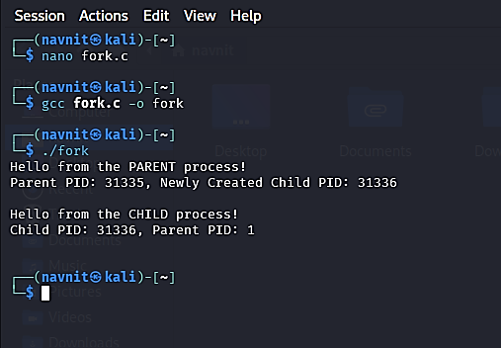
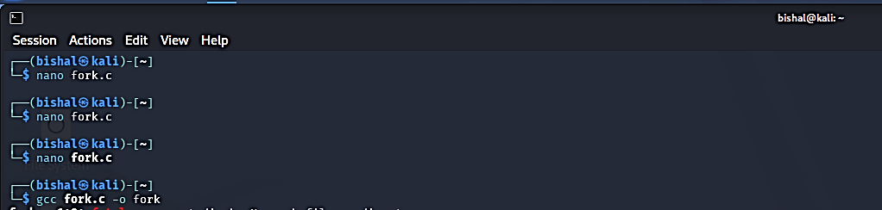

Lab-2: Write a program to simulate producer – consumer problem using semaphore.
Source Code:
import threading
import time
import random

BUFFER_SIZE = 5
buffer = []

empty = threading.Semaphore(BUFFER_SIZE)
full = threading.Semaphore(0)
mutex = threading.Semaphore(1)

def producer():
for i in range(4):
item = random.randint(1, 100)
empty.acquire()
mutex.acquire()
buffer.append(item)
print(f"Producer produced: {item}")
print("Buffer:", buffer)
mutex.release()
full.release()
time.sleep(1)

def consumer():
for i in range(4):
full.acquire()
mutex.acquire()
item = buffer.pop(0)
print(f"Consumer consumed: {item}")
print("Buffer:", buffer)
mutex.release()
empty.release()
time.sleep(1)

p = threading.Thread(target=producer)
c = threading.Thread(target=consumer)

p.start()
c.start()

p.join()
c.join()
print("Producer-Consumer simulation completed.")

Output:
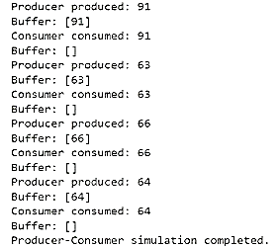

Lab-3: write a program to simulate following CPU scheduling algorithms to find average turnaround time and waiting time.
- FCFS
- SJF
- Priority scheduling
- Round Robin
Source Code:
def fcfs(processes):
wt = [0] * len(processes)
tat = [0] * len(processes)
for i in range(1, len(processes)):
wt[i] = wt[i - 1] + processes[i - 1][1]
for i in range(len(processes)):
tat[i] = wt[i] + processes[i][1]
print("\nFCFS Scheduling")
print("PID\tBT\tWT\tTAT")
for i, p in enumerate(processes):
print(f"{p[0]}\t{p[1]}\t{wt[i]}\t{tat[i]}")
print("Average Waiting Time =", sum(wt) / len(processes))
print("Average Turnaround Time =", sum(tat) / len(processes))

def sjf(processes):
processes = sorted(processes, key=lambda x: x[1])
wt = [0] * len(processes)
tat = [0] * len(processes)
for i in range(1, len(processes)):
wt[i] = wt[i - 1] + processes[i - 1][1]
for i in range(len(processes)):
tat[i] = wt[i] + processes[i][1]
print("\nSJF Scheduling")
print("PID\tBT\tWT\tTAT")
for i, p in enumerate(processes):
print(f"{p[0]}\t{p[1]}\t{wt[i]}\t{tat[i]}")
print("Average Waiting Time =", sum(wt) / len(processes))
print("Average Turnaround Time =", sum(tat) / len(processes))

def priority(processes):
processes = sorted(processes, key=lambda x: x[2])
wt = [0] * len(processes)
tat = [0] * len(processes)
for i in range(1, len(processes)):
wt[i] = wt[i - 1] + processes[i - 1][1]
for i in range(len(processes)):
tat[i] = wt[i] + processes[i][1]
print("\nPriority Scheduling")
print("PID\tBT\tPriority\tWT\tTAT")
for i, p in enumerate(processes):
print(f"{p[0]}\t{p[1]}\t{p[2]}\t\t{wt[i]}\t{tat[i]}")
print("Average Waiting Time =", sum(wt) / len(processes))
print("Average Turnaround Time =", sum(tat) / len(processes))

def round_robin(processes, quantum):
n = len(processes)
remaining = [p[1] for p in processes]
wt = [0] * n
tat = [0] * n
time = 0
while True:
done = True
for i in range(n):
if remaining[i] > 0:
done = False
if remaining[i] > quantum:
time += quantum
remaining[i] -= quantum
else:
time += remaining[i]
wt[i] = time - processes[i][1]
remaining[i] = 0
if done:
break
for i in range(n):
tat[i] = processes[i][1] + wt[i]
print("\nRound Robin Scheduling")
print("PID\tBT\tWT\tTAT")
for i, p in enumerate(processes):
print(f"{p[0]}\t{p[1]}\t{wt[i]}\t{tat[i]}")
print("Average Waiting Time =", sum(wt) / n)
print("Average Turnaround Time =", sum(tat) / n)

processes = [
("P1", 6, 2),
("P2", 8, 1),
("P3", 7, 3),
("P4", 3, 2)
]

fcfs(processes)
sjf(processes)
priority(processes)
round_robin(processes, 2)

Output:
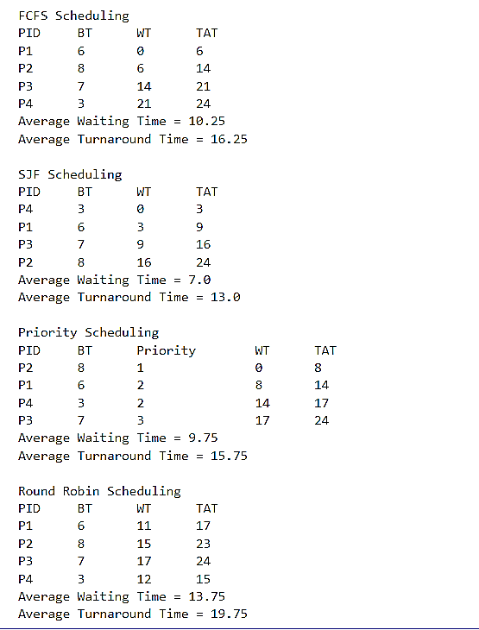

Lab-4: Write program to simulate the following contiguous memory allocation algorithm
- First Fit
Source Code:
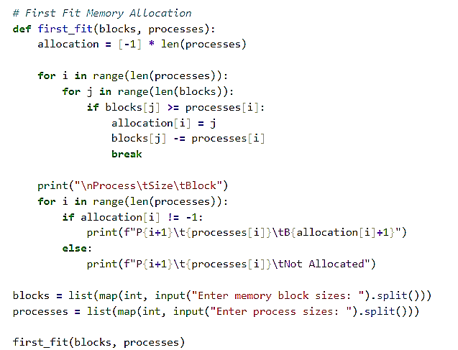

Output:
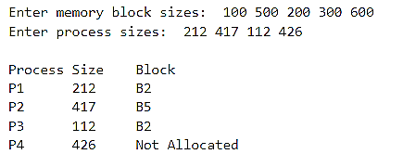

- Best Fit
Source Code:
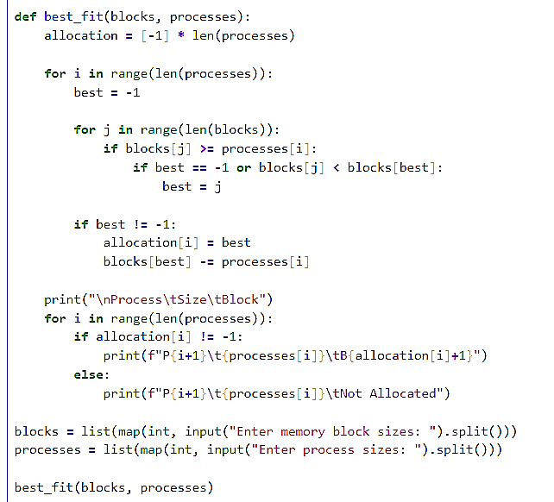

Output:
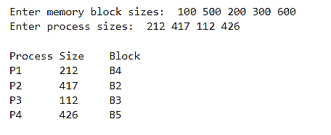

- Worst Fit
Source Code:
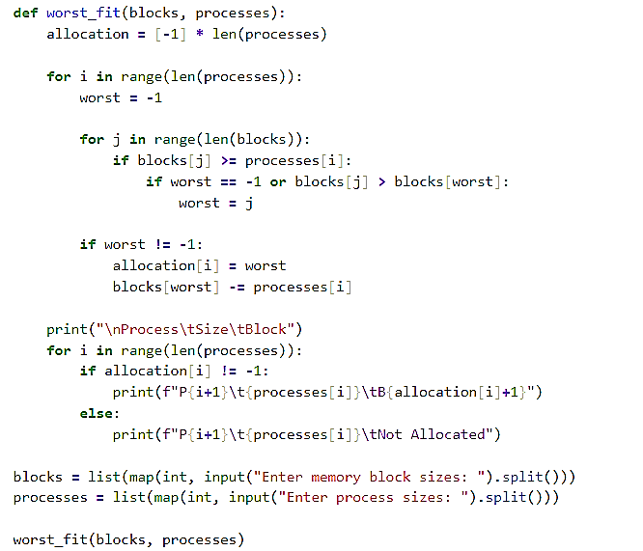

Output:
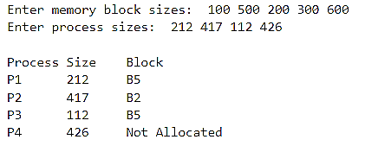

Lab-5: Write a program to simulate following page replacement algorithm and find the page fault
- FIFO
Source Code:
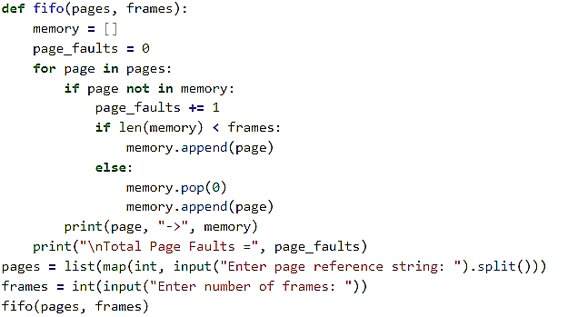

Output:
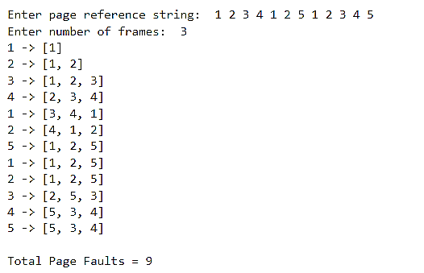

- LRU
Source Code:
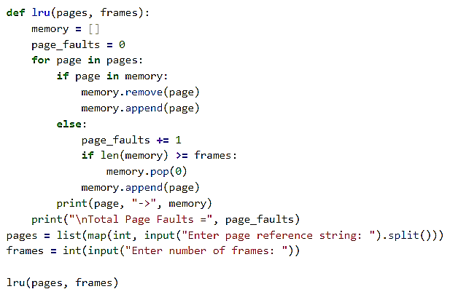
Output:
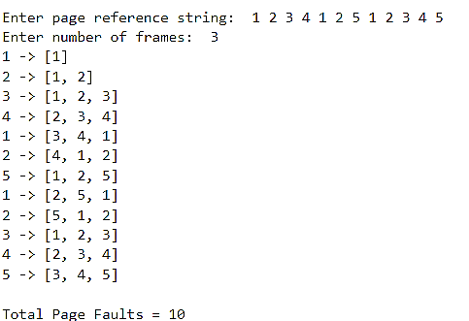

- OPR
Source Code:
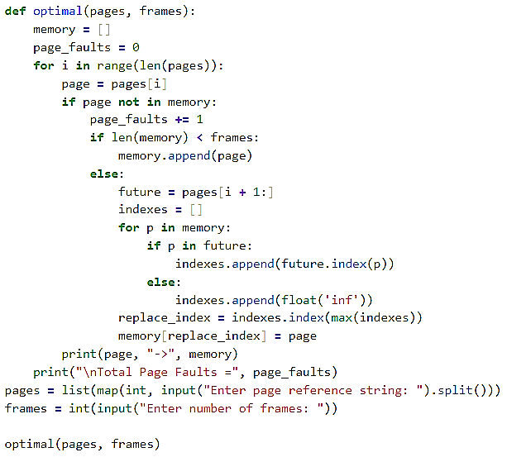

Output:
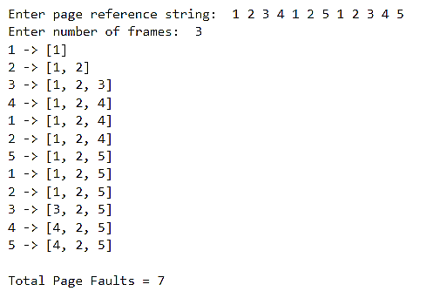

Lab-6: Write a Program to simulate following disk scheduling algorithms
- FCFS
Source Code:
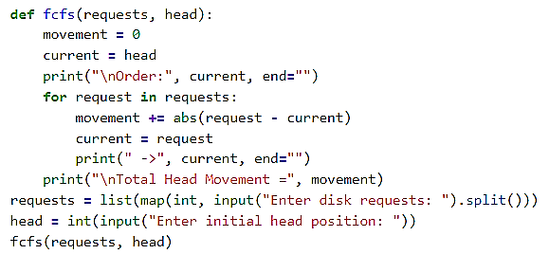
Output:
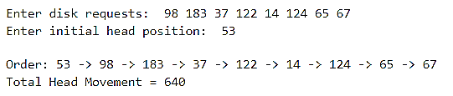

- SSTF
Source Code:
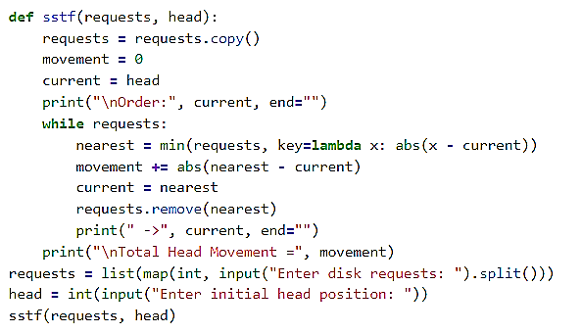

Output:
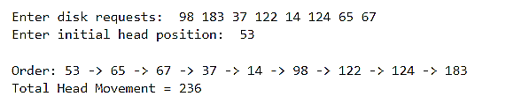

- SCAN
Source Code:
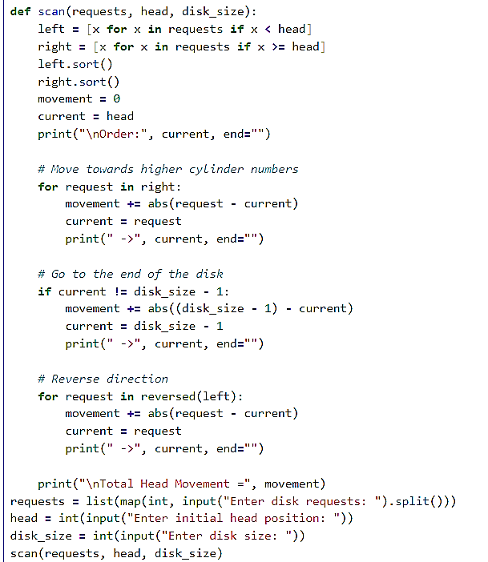

Output:
